***A story of me***

**Chapter three**

*Now that I have arrived at the school, I need to make some friends, because I don’t want to hang around the school alone. Just as I was thinking I bumped to someone, the perfect way to meet. I looked up to see the shyest girl I had ever seen in my life. She had curly, light brown hair and beautiful brown eyes.*

**Unknown girl:** Oh, I am really sorry! Now your dress is ruined with coffee stains.

**Me:** No problem, I was going to change anyway, I hate this dress!

***P.S: Actually, I really DO hate this dress. My mom made me wear it and I was looking for an excuse to change (I have recently bought a new dress which was really fashion forward unlike the one I was wearing right now.)***

**Me:** By the way I am Jessica Brown or shortly Jess. Nice to meet you!

**Unknown girl:** I am Belladonna Roberts or shortly Belle. Nice to meet you to! Can we be best friends? I am really shy in introducing myself and I am sure that if we don’t be friends I will hang around alone for the whole school year!

**Me:** Sure, no problem. By the way, your dress is totally amazing!

**Belle:** Really? I bought it recently! I am so lucky to be friends with you! You are the best looking girl I have seen since coming here!

**Me:** Yeah, of course I am. Anyway for how long did you study in here?

**Belle:** Not that long, but one and a half year.

**Me:** Okay, that’s long enough. So, tell me who is the most popular girl in our year?

**Belle:** Its Blair Willows. Her father is really rich and is friends with principal.

**Me:** She is just famous because of her father is rich, well not any more. My father is millionaire and my family is close friends with the principal’s family. Principals like people who donate money to their schools. My father decided to donate 10,000$ to school.

**Belle:** Well seems like someone will be going down. Oh, there she is. All the new girls are supposed to introduce themselves to her. So she can see if they are good enough to be in her GANG.

**Me:** I will NOT introduce myself to her. I know that I am not good enough I a-

**Belle:** Of course you ARE!

**Me:** I was going to tell I am PERFECT, but thanks for trying to support me anyway.

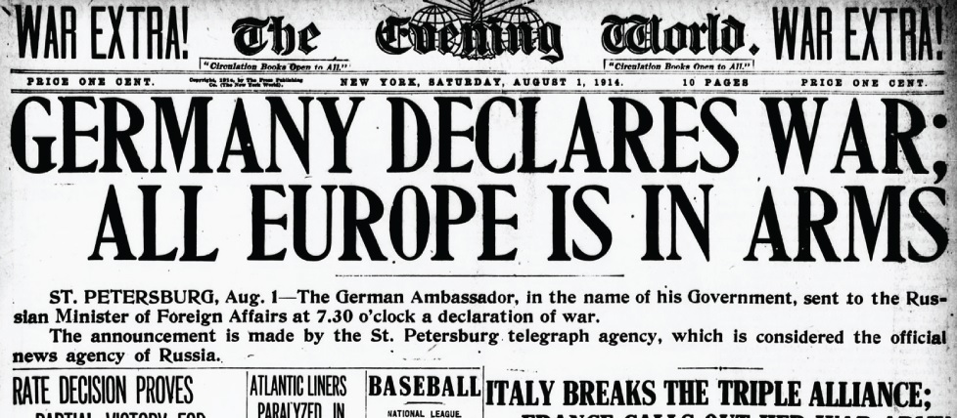*So there stood the most arrogant looking girl I have ever seen. She was looking towards me expectantly, but I pretend not to see her. Even though I was having a friendly conversation with Belle, I knew that I had declared a war with Blair Willows.*